FOOD CONNECT
TO SUPPLY LTEFTOVER FOOD TO POOR
PROJECT OVERVIEW:
This project aims to build a Salesforce-based CRM solution that manages the collection,tracking,and distribution of left overfood from restaurants,hotels,and events to underprivileged communities.The system designed to streamline donor management,volunteer coordination,and food distribution logistics,ensuring minimal food wastage and maximum rich to beneficiaries.Key features include donor registration,food pickup scheduling,real time tracking of food request,and automated notification for stakeholders.The CRM addresses the business need of improving food distribution efficiency,transparency,and accountability.

OBJECTIVES:
- To automate donation tracking and pickup scheduling for timely food connection.
- To provide stakeholders with realtime visibility into donation status,logistics,and distribution.
- To ensure food wastage reduction and channel surplus food to the needy in an organizated manner.

Custom Object and Tabs:
For managing entities venue,drop-off point,task,execution details,volunteers.
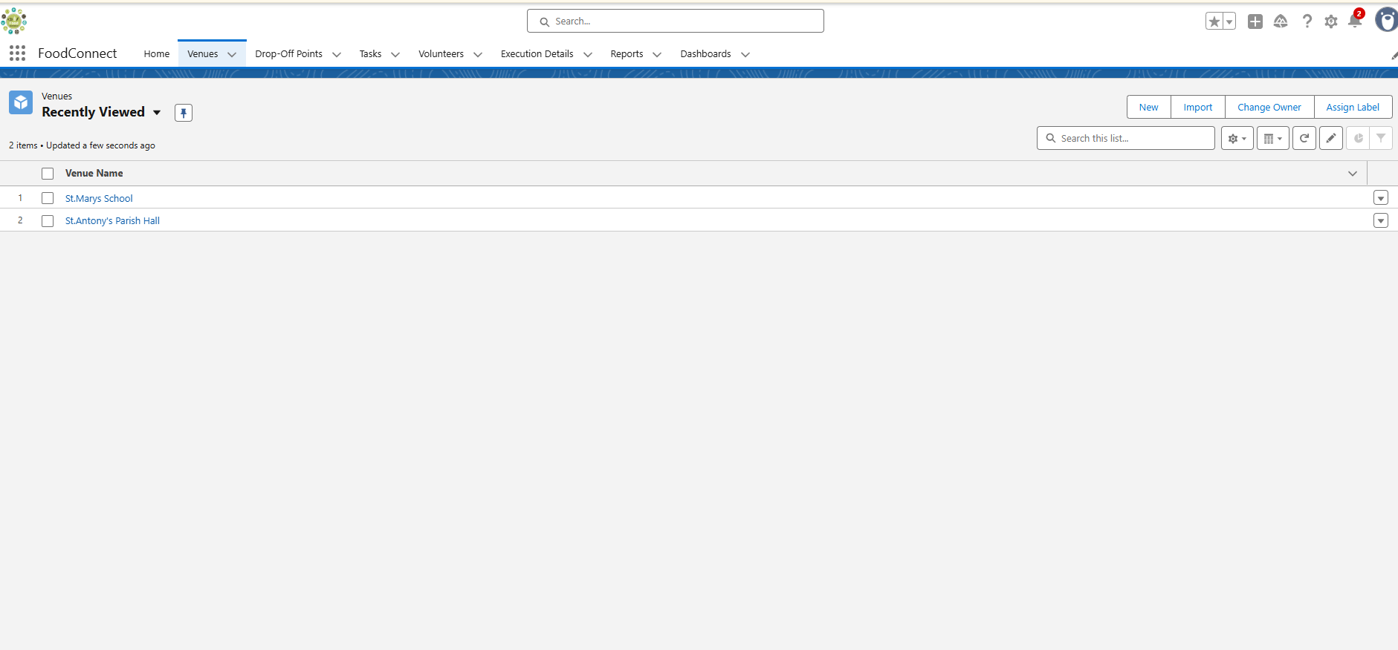

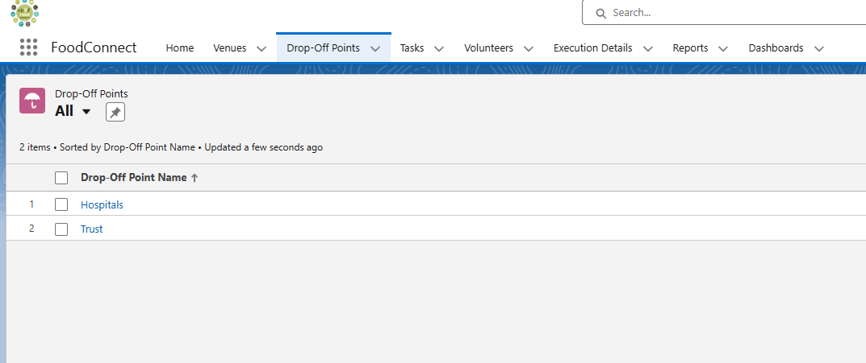

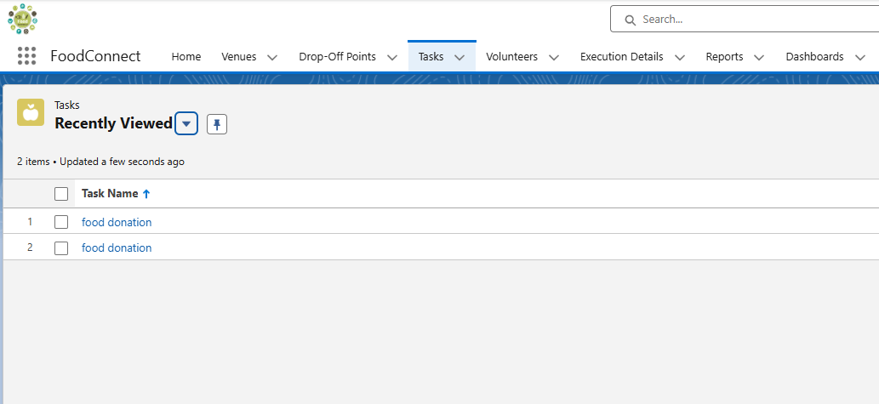

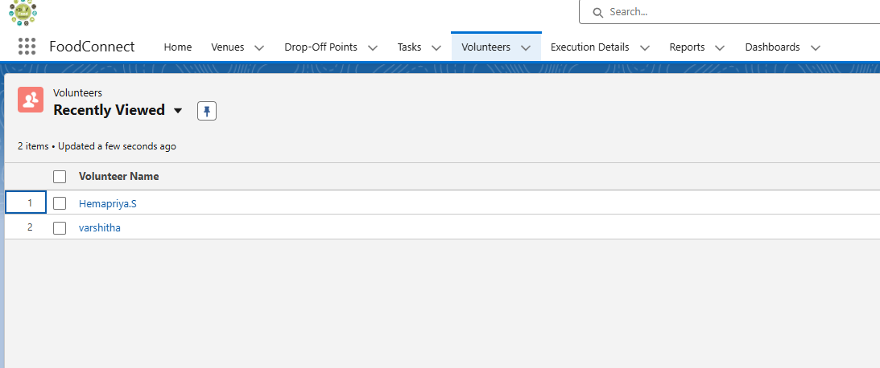

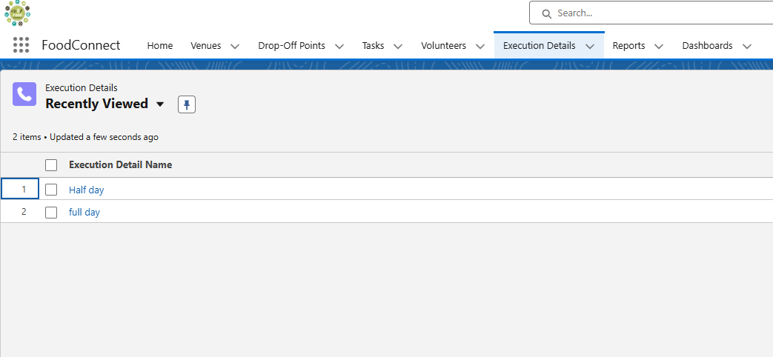

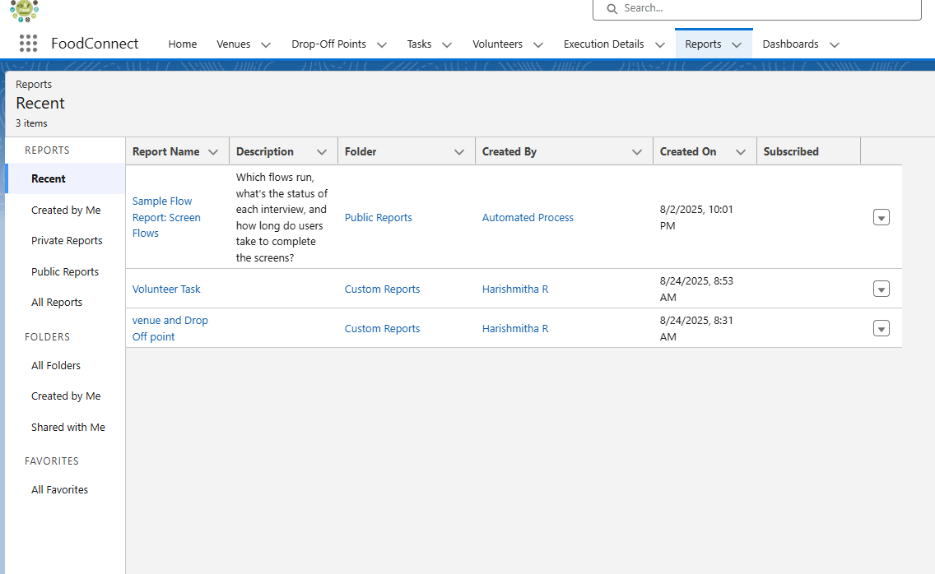
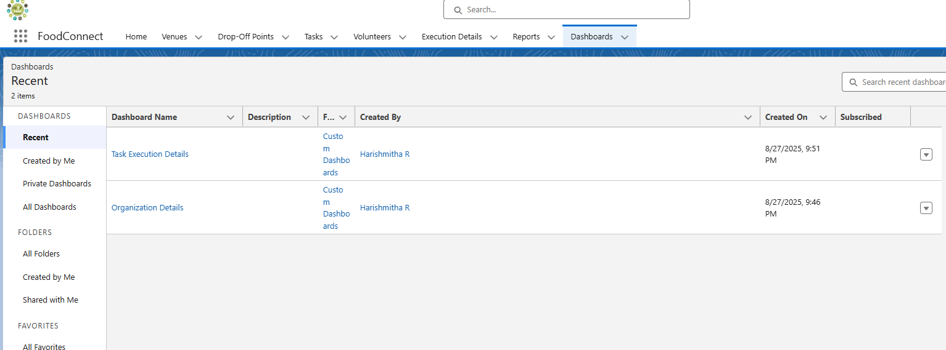

HOME PAGE:
Set up the homepage to highlight key metrics and provide stakeholders with quick access links.

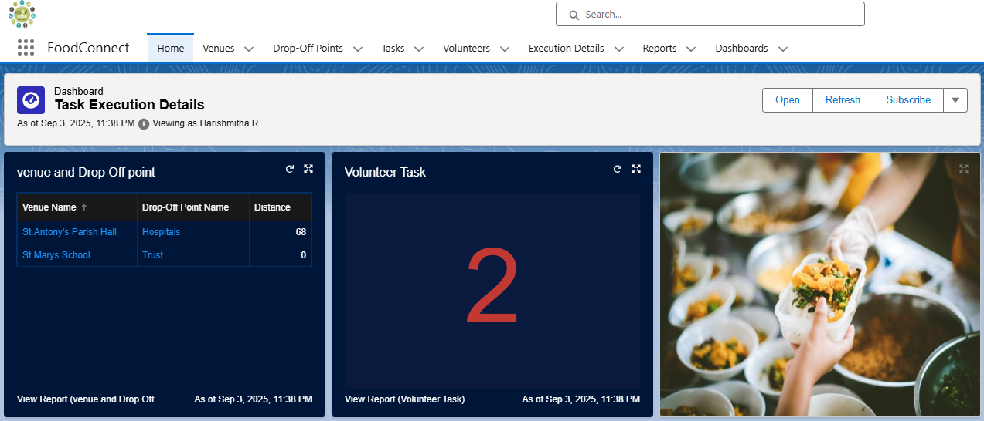

LIGHTING APP:
Developed a customized app designed for easy navigation and enhanced accessibility.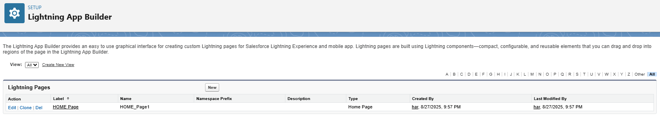
FLOWS:
- Donors log donation via a form,automatically creating a food donation record.
- Assigns volunteers based on avalibility and proximity.
- Sends automated SMS/E-mail to volunteers and beneficiaries about pickup and delivery.

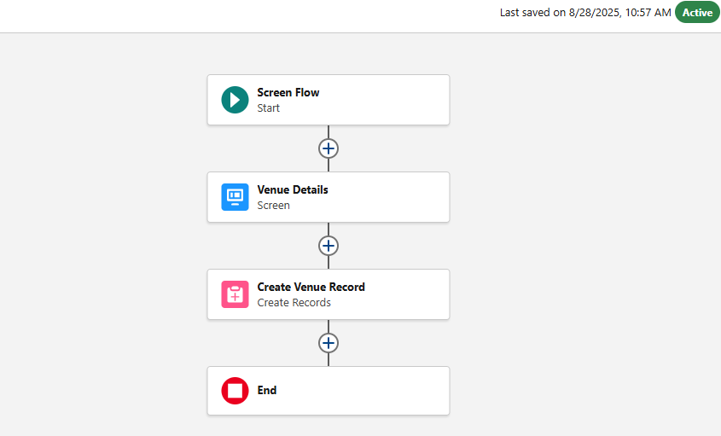
VALIDATION RULES,APPROVAL PROCESSES AND AUTOMATION:
- Food donation cannot be created without specifying quantity and expiry time.
- Beneficiary record require a valid contact number for confirmation.
- Large food donation approval by an NGO admin before dispatch.
- E-mail alerts when a donation is created.
- Task assignment to nearest available volunteer.
- Auto-updating donation status to “Deliverd” once a distribution record is submitted.
TESTING APPROCH:
UNIT TESTING: Tested flows for food donation submission,volunteer assignment, and beneficiary notifications.
USER ACCEPTANCE TESTING: Conducted with a small group of donors,volunteers,and beneficiaries to validate usability and accessibility.
CONCLUSION:
The Salesforce based on food supply management CRM successfully addresses the challenge of food wastage while supporting social good by connecting donors,volunteers,and beneficiaries.With its automation,streamlined workflows,and reporting capabilities,the system ensures transparency ,accountability and maximum utilization of leftover food.

